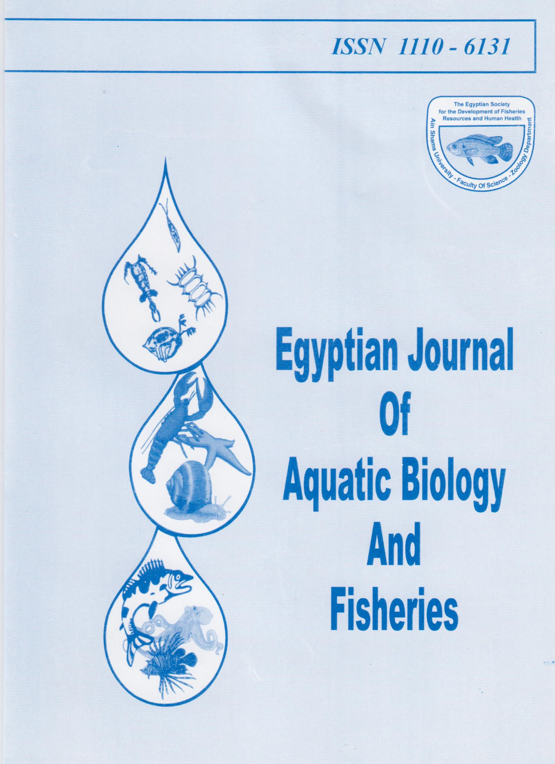
Egyptian Journal of Aquatic Biology & Fisheries
Zoology Department, Faculty of Science,
Ain Shams University, Cairo, Egypt.
ISSN 1110 - 6131 Vol. 22(2): 103- 118 (2018)

ejabf.journals.ekb.eg

A novel three dimensional Carbon Nanotube-polyethylene glycol-Polyvinyl alcohol Nanocomposite for Cu(II) removal from water

Eman Serag¹; Ahmed El Nemr¹*; Shadia A. Fathy²; Fatma F. Abdel Hamid² and Azza El-Maghraby³
- Marine Pollution Department, Environmental Division, National Institute of Oceanography and Fisheries, Kayet Bey, Elanfoushy, Alexandria, Egypt
- Department of Biochemistry, Faculty of Science, Ain Shams University, Cairo, Egypt
3- Fabrication Technology Department, Advanced Technology and New Materials Institute, City for Scientific Research and Technology Application, Borg El-Arab, Alexandria, Egypt
* Corresponding authors: E-mail: ahmedmoustafaelnemr@yahoo.com; ahmed.m.elnemr@gmail.com

ARTICLE INFO | Abstract
Article History:  Received: May 19, 2018  Accepted: June 7, 2018  Available online: June 2018  _______________  Keywords:  MWCNTs  Polyvinyl alcohol  polyethylene glycol  wastewater  hydrogel | Multiwall carbon nanotube-polyethylene glycol and poly vinyl alcohol (MWCNTs-PEG-PVA) nanocomposite hydrogel was fabricated and used for the Cu (II) ions removal from water with high efficiency. The prepared nanocomposite hydrogel was characterized using Scanning electron microscope (SEM), Fourier transform infrared spectroscopy FTIR, X-ray diffraction (XRD), thermogravimetric analyzer TGA and mechanical properties. A series of systematic batch adsorption experiments were conducted to study the adsorption property of MWCNTs-PEG-PVA hydrogels prepared with different concentrations of MWCNTs. Studying the effects of adsorption parameters such as pH, contact time, and initial concentration were evaluated in a batch system. The high adsorption capacity, easy regeneration and effective adsorption–desorption results proved that the prepared MWCNTs-PEG-PVA composite hydrogel could be an effective adsorbent in removing Cu (II) ion from its aqueous solution. The maximum adsorption capacities were found to be 645.1, 334.4, 238.09 and 185.09 mg g^{–1} for MWCNTs-PEG-PVA hydrogel with 0.05, 0.10, 0.15, and 0.2 % MWCNTs, respectively at pH 6. Isotherm studies revealed that Langmuir model well described the equilibrium data of Cu (II) compared with Freundlich isotherm model. Kinetics studies of Cu (II) adsorption followed pseudo-second order model. The removal efficiency of the recycled MWCNTs-PEG-PVA hydrogel was 79.3, 76.4, 73.8, 70.1 and 65.5 % for five cycles, which demonstrated efficient reusability.
INTRODUCTION

Water treatment processes are one of the major basics for developing, growing the economy as well as maintaining the health. Recently, several efforts have been made to improve the decontamination of the water from heavy metals, synthetic dyes, and aromatic pollutants (El Nemr, et.al, 2009, El Nemr, et.al, 2010, El-Sikaily, et.al, 2012, Ma, et.al, 2017).
Therefore, it is important to find nonconventional ways to remove toxic contaminants from water with high efficiency and less energy consumption (El Nemr, 2012). However, the traditional adsorbent materials, including activated carbon, silica, metal oxides, and polymer resins, suffer from either low adsorption capacities or low efficiency (Gao, et.al, 2013). The design of nanostructured adsorbents with controlled functionalities offers new potentials to address these problems because of their high specific surface areas and more active sites (Olvera, et.al, 2017). Carbon based nanomaterials, especially carbon aerogels, carbon nanotubes (CNTs), graphene, and their composites, represent a promising type of adsorbents for wastewater treatment, and have demonstrated their potential applications for removal of a range of heavy metals and organic contaminants (Sadegh, et.al, 2017).
Due to the large surface areas, good electrostatic interaction, and excellent mechanical and chemical properties, the multi-walled carbon nanotubes (MWCNTs) exhibited higher adsorption capacity for heavy metal ions removal (Brumfiel, 2003). Otherwise, the residual of nanomaterials if not completely removed are most likely to cause many side-effects in the environment (Sadegh, et.al, 2016). As a result, an additional step, such as filtration [Theron, et.al, 2008], high-speed centrifugation (Savage & Diallo, 2005 and Dil, et.al., 2017), or magnetic separation [Machida, et.al, 2006], is usually necessary to collect these highly dispersed nanomaterials, which increase the operational cost in their practical applications.
To overcome the challenges mentioned above, this work aimed to report the preparation of new MWCNTs-polyvinyl alcohol-polyethylene glycol hydrogel and study its application for Cu (II) ion removal from its aqueous solution.

MATERIALS AND METHODS

Materials
PVA (Mw ~ 72,000 g mol^{–1}, 99% of hydrolysis), and PEG (Mw ~ 2,000 g mol^{–1}) were purchased from Aldrich and used as received. Nitric acid, sulfuric acid, sodium hydroxide, copper sulphate pentahydrate, glutaraldehyde and hydrochloric acid, from El-Nasr Co. Egypt, were used without further purification.
Synthesis and functionalization of MWCNTs
The MWCNTs was synthesized via chemical vapor deposition (CVD) of Fe₅₀/Co₅₀/ supported by Al₂O₃ and acetylene as a carbon source. The CVD system consisted of a horizontal quartz reactor (Nabertherm B180-70 cm long, 5.0 cm in diameter) housed in a one stage cylindrical furnace. The reactor was heated at the rate of 50 °C min^{–1} to reach the desired temperature under nitrogen gas with flow of 70 ml min^{–1}. Acetylene (C₂H₂) was then passed through the reactor tube at the rate of 30 ml min^{–1} for 60 minutes. The flow of gases was controlled by a mass flow controller. Then, the reactor was cooled under a flow of nitrogen (40 ml min^{–1}) to room temperature. MWCNT synthesis by Chemical vapor deposition is heterogeneous reactions in which both solid and volatile products are form from a volatile precursor through chemical reactions, and the solid products are deposit on a substrate.
The grown MWCNTs were characterized by SEM and TEM. The oxidation of MWCNTs was carried out according to Pham et al. (Pham et al, 2011). This treatment produced carboxylic groups (COOH) on the surface of the MWCNTs, which help the dispersion of MWCNT through the polymers.
Preparation of Hydrogels
MWCNTs-polyethylene glycol-Polyvinyl alcohol (MWCNT-PEG-PVA) nanocomposite hydrogel was prepared by dissolving PVA (10.0 g) in deionized water (100 ml) at 90°C under magnetic stirring. PVA solution was left to cool down to room temperature, then different concentrations of MWCNTs (0.5, 0.1, 0.15, and 2%) were dispersed in PVA solution under magnetic stirring, PEG (5 ml) was added to the solution followed by addition of (10 mL of 2.5% glutaraldehyde solution and 1% concentrated HCl, which act as the cross linking agent and catalyst, respectively and continues stirring for 15 min (Abraham, et.al, 2012). The hydrogel was dried overnight in an oven at 80 °C until the complete evaporation of its water content.
Characterization of nanocomposite hydrogel
The morphology of the prepared hydrogel was examined by scan electron microscope (SEM) (JEOL, Model JSM 6360LA, Japan). Fourier transform infrared spectroscope (FTIR) data were obtained using Bruker VERTEX 70 spectrometer in the range of 4000–400 cm^{–1} connected with Platinum ATR unit, Germany, X-Ray diffractometer (Schimadzu-7000). The thermo-gravimetric analysis (TGA) was performed on a TGA-50-Schimadzu, Japan from 50 to 600 °C at a heating rate of 10 °C min^{–1} under nitrogen gas. The tensile strength and elongation degree of the hydrogels have been measured with tensile test machine (model: AG-I/50–10KN, Japan).
Water uptake capacity of MWCNTs nanocomposite hydrogel
The ability of the MWCNTs nanocomposite hydrogel to absorb medium was studied to understand the diffusion of the medium into the hydrogel, which is essential for heavy metal removal application. The nanocomposite hydrogel was immersed directly in certain amount of deionized water at room temperature for 120 min, the samples were taken out from water at certain time intervals (every 10 min), then rapidly dried gently with filter paper to remove the excess water, and subsequently weighed to define Ws and after the swollen product was dried at 50 °C to a constant weight (W_{d}). The percentage of swelling ratio of the product was calculated as per the following equation (Yang, et.al, 2008):

(1)

where W_{S} is the weight of the swollen hydrogel and W_{d} is the weight of dried hydrogel.
Batch adsorption experiment
In typical batch experiments, the hydrogels were swelled in 100 mL of Cu (II) solution on a rotary shaker at 200 rpm using 250 mL capped conical flasks and agitated for the required contact time at room temperature (25±1 °C). The pH of the solution was adjusted by adding appropriate amounts of 0.1 M NaOH or 0.1 M HNO₃ to obtain the desired pH. The effect of pH, amount of adsorbent, initial Cu (II) concentration, and contact time were studied in order to determine the optimum conditions necessary for Cu (II) ions removal from aqueous solution.
The concentration of Cu (II) was determined through a spectrophotometer using 1-(2-pyridylazo)-2-naphthal (PAN) solution at 550 nm (Sarker & Ullaha, 2013). The amount of Cu (II) ions adsorbed at equilibrium q_{e} (mg/g) was calculated using equation 2 (Ajitha, et.al, 2017).

(2)
where C₀ represents the initial ion concentrations (mg/L), C_{e} is equilibrium Cu ion concentrations (mg/L), V is the volume (L) of the adsorbate solution and m represents the adsorbent mass in g/L.
Recyclability experiment
The adsorbed Cu (II) ion on the adsorbent was eluted with 0.1 M HCl solution, then the adsorbent was treated with 0.1 M NaOH solution to neutralize the hydronium ion (H₃O⁺) on the hydrogels, and the adsorbent was further washed with deionized water (Haung, et.al, 2012). The regenerated hydrogels were subjected to batch adsorption in the next cycles.

Results AND DISCUSSION

Characterization of the nanocomposite hydrogel
Fig. 1 (a, b) illustrates the SEM and TEM of MWCNTs synthesized by the CVD method. As observed from Fig. 1a, MWCNTs have appropriate density and are entangled and free from amorphous carbon. TEM image of MWCNTs (Fig. 1b) confirms that the CNT is multi-wall and also has highly pure structure, and the outer diameter is around 20-60 nm. SEM images of surface morphology of PVA-PEG hydrogel, and MWCNTs-PEG –PVA nanocomposite hydrogel were reported in Fig. 1 (c, b). It has been observed that there is difference between SEM images for both hydrogels where there is lighting dots in the scan micrographs in Fig. 1(d) represent MWCNTs with uniform dispersion into the nanocomposite.
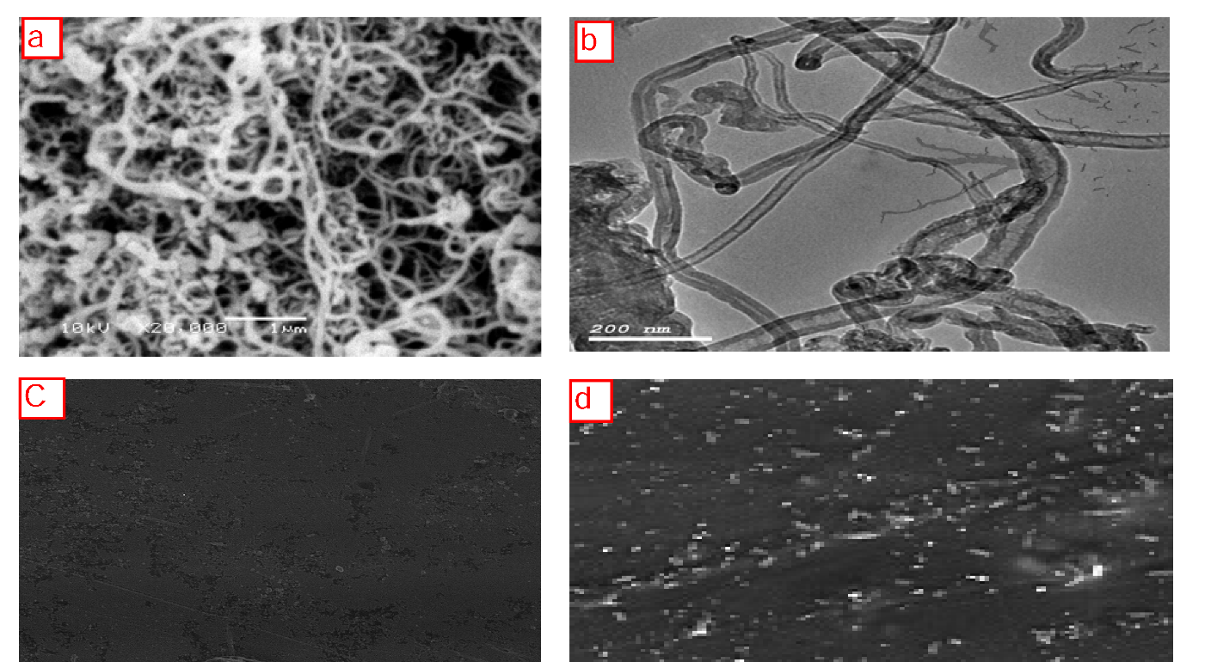

Fig. 1: a) SEM image of synthesized MWCNTs, (b) TEM image of MWCNTs, (c) SEM image of PVA-PEG hydrogel, (d) SEM image of (0.1 %) MWCNTs-PVA-PEG hydrogel.

Fig. 2 shows FTIR of PVA-PEG, and (0.1 %) MWCNTs-PVA-PEG nanocomposite hydrogel. The hydroxyl stretching band was observed at 3294 cm⁻¹ and the band at 1088 cm^{–1} was the proof of C-O bond. These two peaks were clear evidences of the successful attachment of PVA on the MWCNTs surface [Mansur, et.al, 2004]. it was observed that the intensity of these bands decreased with the addition of MWCNTs to the polymeric structure and that agreed with the result reported by Özkahraman and Irmak in 2017 [Özkahraman & Irmak, 2017]. The peaks at 2922 cm⁻¹ is the characteristic band of alkyl (CH in CH₂) groups of the polymers PVA and PEG.
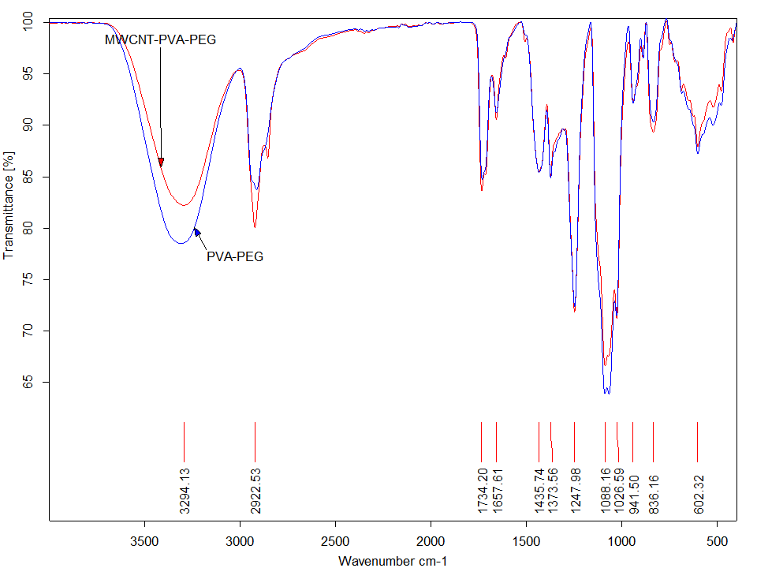

Fig. 2: FTIR of PVA-PEG hydrogel and (0.1 %) MWCNTs-PVA-PEG nanocomposite hydrogel.

The stretching vibrational bond of C=O at 1734 cm^{–1} increases by adding MWCNTs to the hydrogel membrane, which can be attributed to the carbonyl groups of acid treated MWCNTs (Yan, et.al, 2007, Naskar, 2010). The band at 1657 cm⁻¹ region is likely due to the conjugation of C=O with C=C bonds or interaction between localized C=C bonds, C=O in carboxylic acids and ketones that indicated the presence of MWCNTs, PVA, and PEG (Yan, et.al, 2007). The absorption band at 1435 cm^{–1} is assigned as CH₂ bending vibration while the deformation vibration of C–CH₃ is associated with the absorption band at 1373 cm^{–1} (Suzuki, 2015). The peaks at 1247 cm^{–1} are due to C-O stretching mode, which are contributions from both the PVA and PEG.
Fig. 3 shows XRD Result of PVA-PEG, and (0.1%) MWCNTs-PEG-PVA nanocomposite hydrogel. It was observed that MWCNTs-PEG-PVA hydrogel with higher and sharper intensity peak (127 a.u.) at 2Ө = 19.9 that can be explained by the presence of crystalline MWCNTs which will contribute to increase the crystallinity of the polymers (Malikova, et.al, 2014). Otherwise, the observed peak for MWCNTs pattern, was not present in the nanocomposite hydrogel, which indicated the good dispersion of MWCNTs into the nanocomposite.
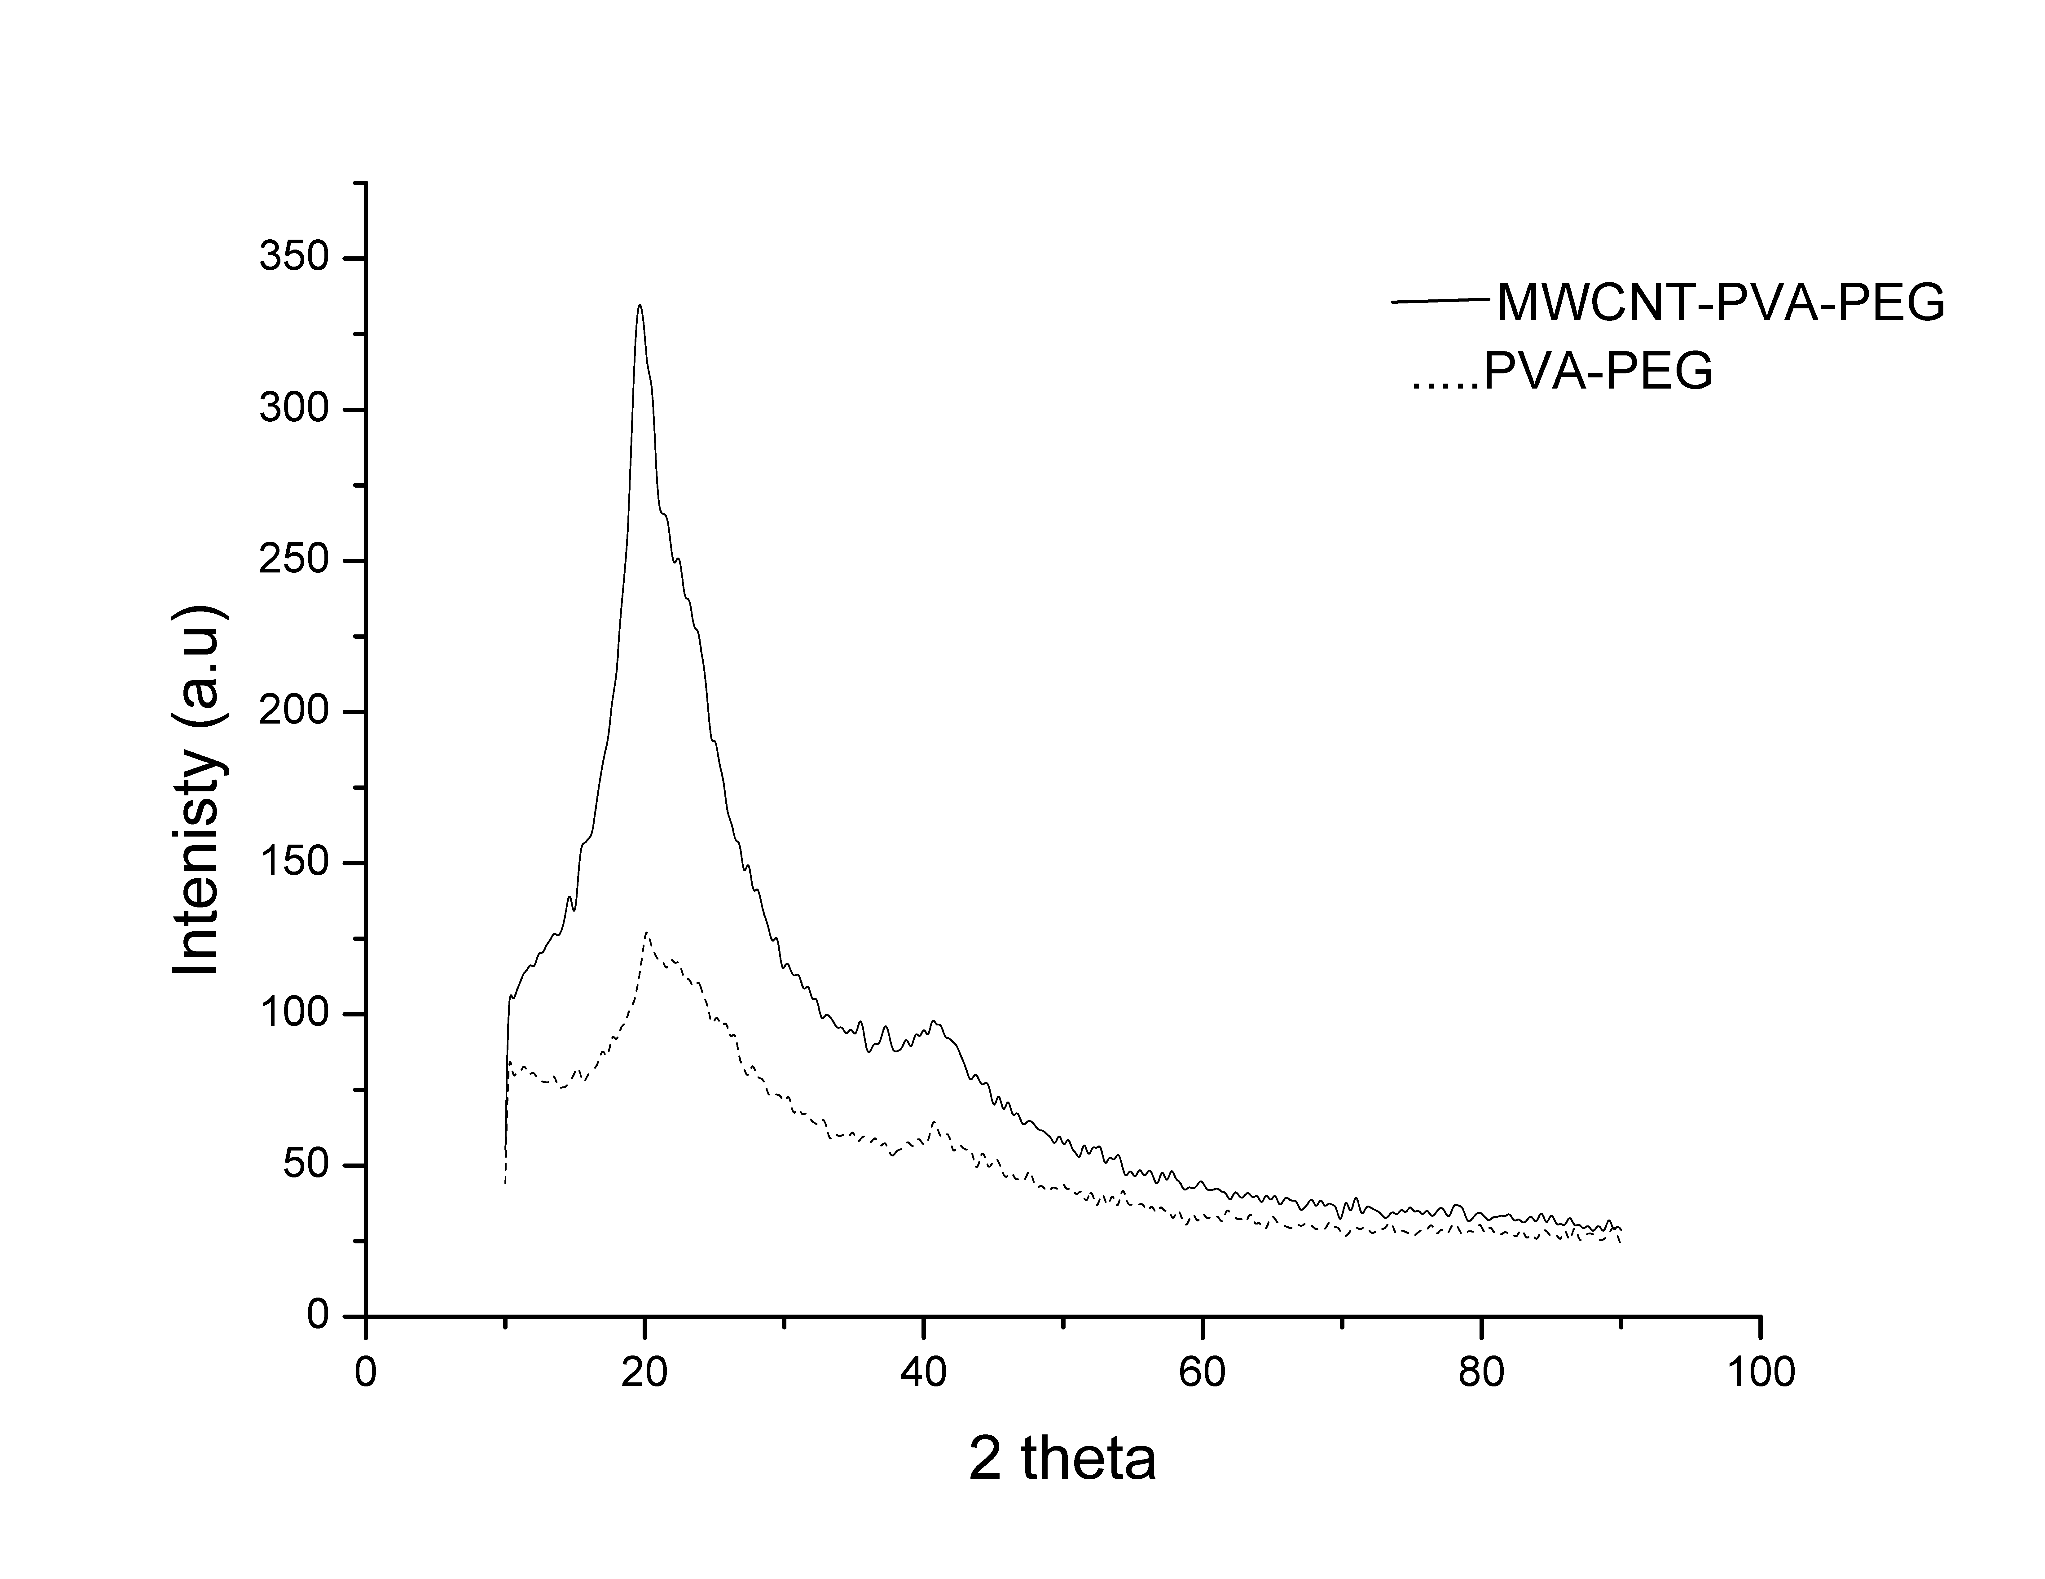

Fig. 3. XRD pattern of PVA-PEG hydrogel, and (0.1 %) MWCNTs-PVA-PEG hydrogel.
Fig. 4 shows TGA at temperature range 25–600 °C for nanocomposites hydrogels. The weight loss occurred in four temperature zones: > 150; 150–250; 250–400, and 400–500 °C. The initial weight loss occurred below 150 °C due to the loss of water content. The major loss in the weight of the hydrogels was occurred between 300 and 500 °C due to the decomposition of the polymers [Abu Ghalia & Dahman, 2015]. Incorporation of MWCNTs as nanofiller into PVA-PEG showed higher thermal stability and char residue than that without MWCNTs which may be attributed to the incorporation of MWCNTs that leads to overlapped degradation region of the polymers and enhanced thermal stability ([Naskar, 2010, Yan, et.al, 2012).

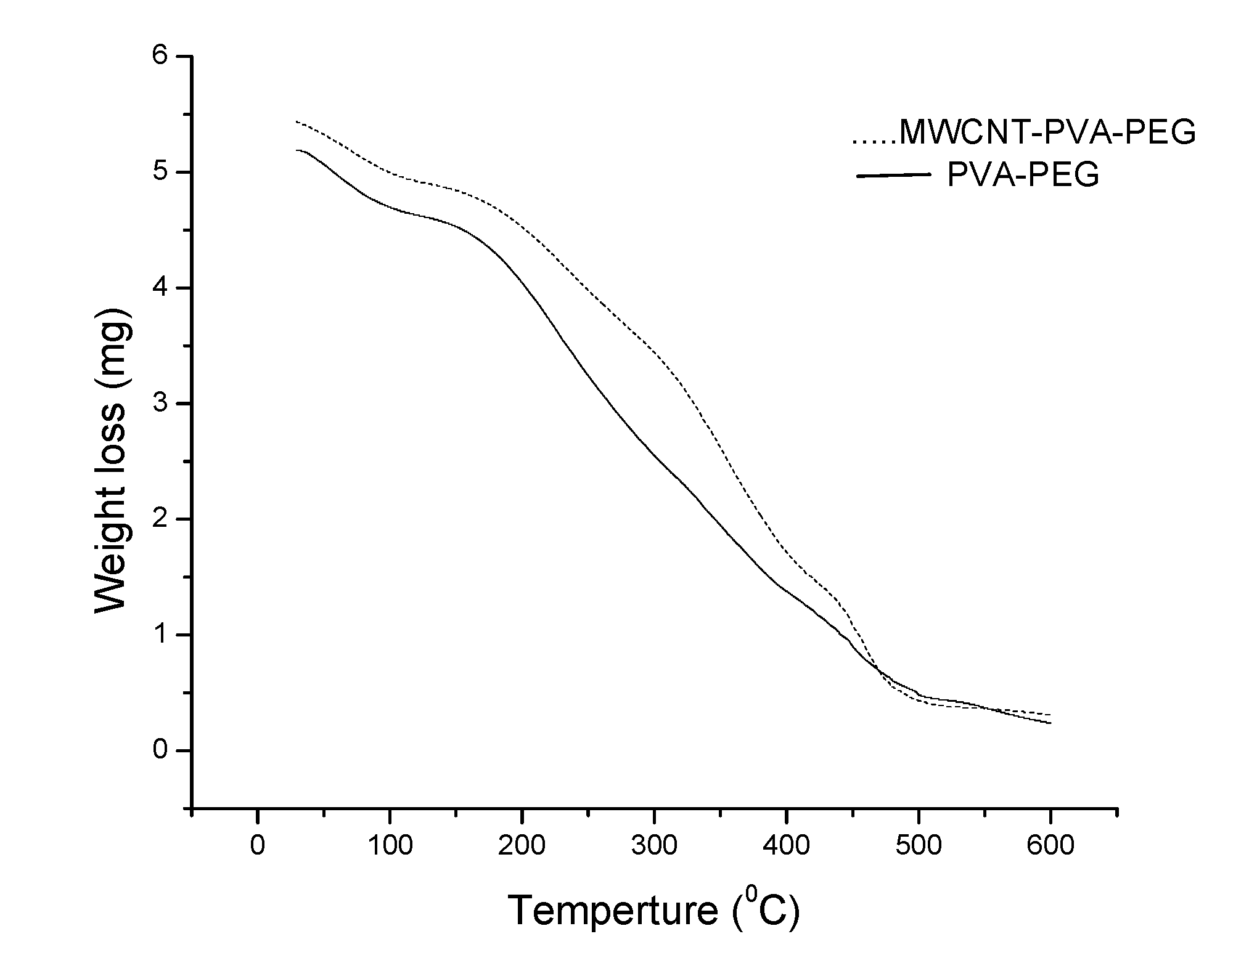

Fig. 4: Thermal gravimetric analysis of PVA-PEG hydrogel, and (0.1 %) MWCNTs-PVA-PEG nanocomposite hydrogel.

Mechanical properties of the hydrogel
The Presence of MWCNTs in the nanocomposite matrix increases the mechanical properties of the nanocomposites PVA-PEG hydrogel as reported in Table 1, where MWCNTs is an ideal reinforcement element. The load of MWCNTs on the polymers transferred the elastic modulus (0.1–1 TPa) and the axial strength (10–150 GPa) of MWCNTs to the composite hydrogel (Yan, et.al, 2012).
And it was seen that the mechanical properties in this study of PVA/PEG, and PVA/PEG/ MWCNT were comparably higher than those of the mechanical of poly (acrylamide-co-sodium methacrylate/ carboxy-MWCNTs (liue, et.al, 2012) as shown in Table 1.

Table 1: The comparison between the tensile strength of MWCNTs nanocomposites in this study with the literatures.
MWCNTs nanocomposite | Tensile strength | Elongation % | Reference
PVA/PEG | 1.2 | 100 | This work
PVA/PEG/ (0.1 %)MWCNTs | 2.48 | 145 | This work
poly( acrylamide-co-sodium methacrylate/ carboxy-MWCNTs | 0.049 | 74.7 | (liue, et.al, 2012)
STYRENE-ACRYLIC / MWCNTs | 16 | 216 | (Volynets, et.al,2017)
PVA/MWCNTs | 15 | 174 | (Volynets, et.al,2017)
Cellulose/MWCNTs | 40.7 | 10.46 | ( Lu & Hsieh, 2010)

Fig. 5 shows the swelling behavior of the PVA-PEG, and MWCNTs-PVA-PEG nanocomposite hydrogels in distilled water as a function of time. A saturation value of approximately 248 and 280% for PVA-PEG hydrogel and (0.1 %) MWCNTs-PVA-PEG hydrogel, respectively, were gradually achieved within approximately 120 min. The swelling ratio of the hydrogels containing MWCNTs are higher than that of hydrogel in absence of MWCNTs and this may be attributed to MWCNTs that increase the inter space between the polymer molecules and allows penetration of water molecules into hydrogels network and increases swelling ratio (Yun, et.al, 2011). MWCNTs increases the swelling capability of the nanocomposite hydrogels and this is similar to adding 0.5% MWCNTs to Poly(vinyl alcohol) (PVA)/poly(acrylic acid) (PAAc)/poly(N-isopropylacrylamide) (PNIPAAm) nanocomposite (Jung, et.al, 2012).
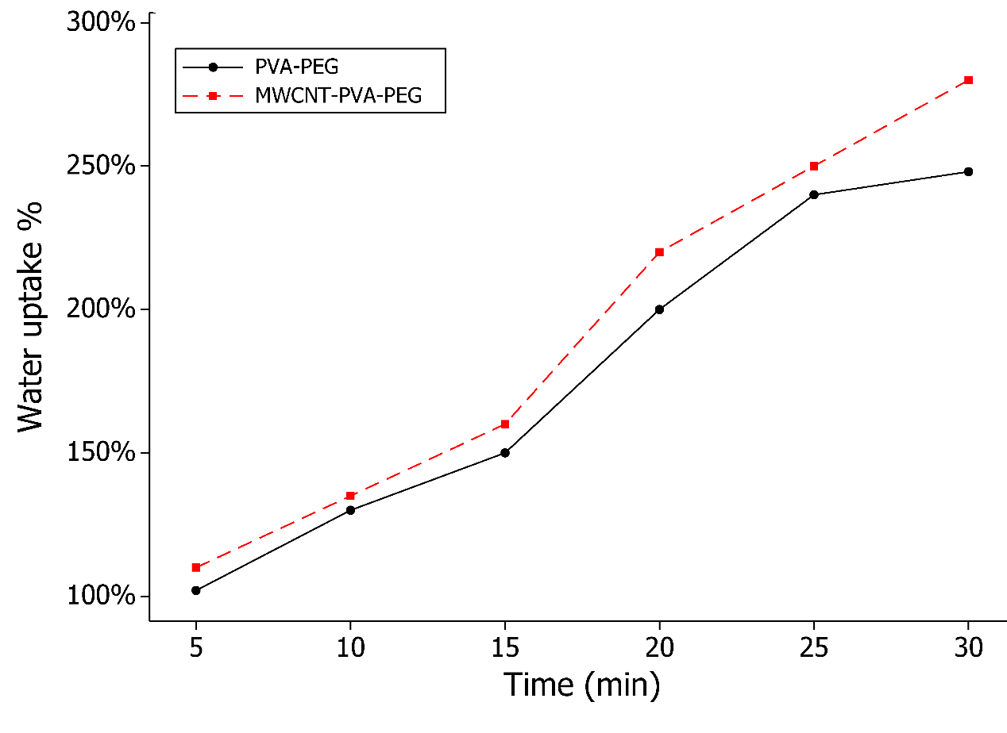

Fig. 5. Water uptake % of PVA-PEG, and MWCNTs-PVA-PEG nanocomposite hydrogels

Adsorption experiments
Adsorption processes were carried out to investigate the effectiveness and efficiency of the new prepared MWCNTs nanocomposite hydrogels for the sorption of Cu (II) ion from water. The role of various parameters that influence adsorption such as pH, contact time, adsorbent dose, and initial adsorbate concentration were investigated to ascertain the ideal conditions suited for Cu(II) ion removal. kinetics, and isotherm studies were also carried out by using the data obtained.
Effect of pH.
The extent of adsorption of Cu(II) ion onto the studied adsorbents was investigated at different pH values ranging from 3.0 to 7.0, at 200 mg/L of Cu(II), (0.1%) MWCNTs into the hydrogel, and at 25 °C. Removal of Cu(II) ion from aqueous solution is usually affected by the initial pH of the solution, since it affects the surface charges present on the adsorbent (Oyetade, et.al, 2016). From Fig. 6, it was observed that the efficiency of Cu(II) ion removal increased when pH increased from 3 to 6, then the efficiency of Cu(II) ion removal decreased when pH increased to pH 7. This may be attributed to that at low pH (pH = 3) an excess H₃O⁺ competes with Cu²⁺ ion on the adsorption site resulting in a low level of adsorbed Cu²⁺ ion. When the pH level increases to pH 6, the covered H₃O⁺ ions leave the MWCNTs-nanocomposite hydrogel surface and made the sites available to Cu²⁺ ion. This condition suggests that an ion-exchange mechanism (H⁺/Cu²⁺) may be included in the adsorption of Cu²⁺ ion. In addition, the negative charge on the surface of MWCNTs-nanocomposite hydrogel increases because the oxygen-containing functional groups become deprotonated with the increase in pH value. Hence, the electrostatic attraction between MWCNTs-nanocomposite hydrogel and Cu²⁺ ion is enhanced, and this further increases the adsorption amount of Cu²⁺ ion (Jamnongkan, et.al, 2014). On the other hand, when the pH reach 7, the adsorption decrease and this due to precipitation of Cu ion as Cu (OH)₂ (Najam, et.al, 2016).

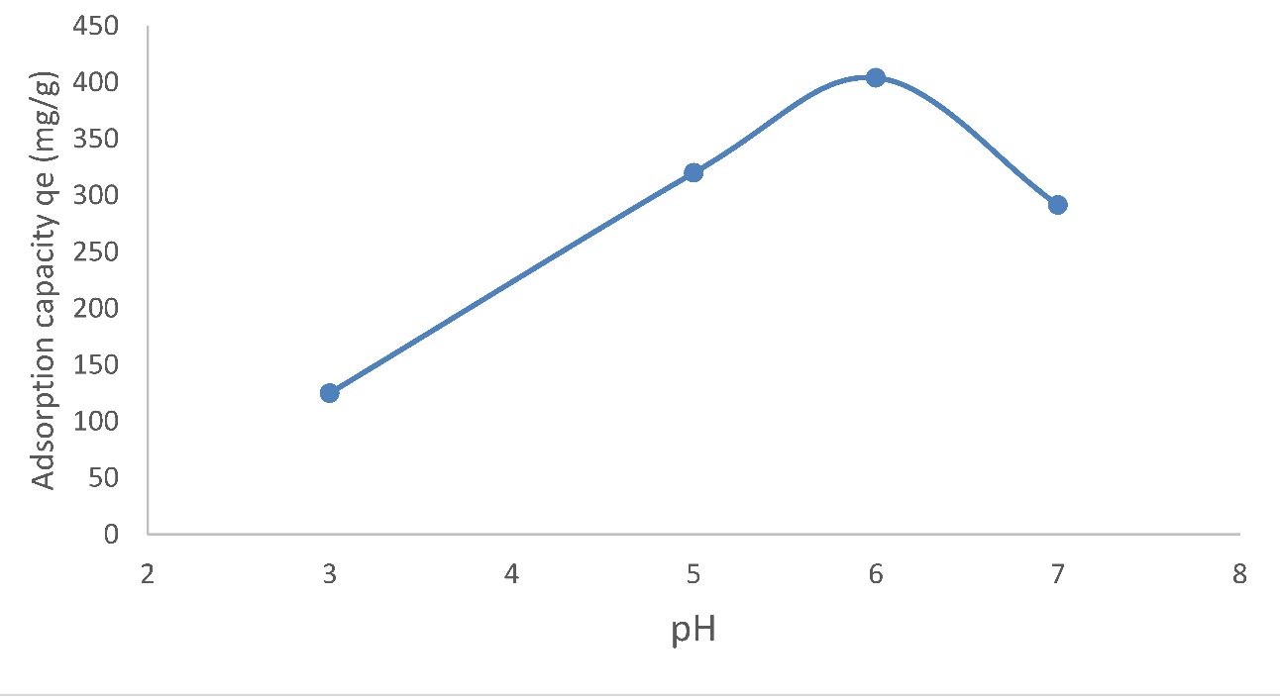

Fig. 6. Effect of pH value on the Cu(II) ion adsorption process using (0.1 %) MWCNTs-PVA-PEG nanocomposite hydrogel.

Effect of contact time and adsorbent dose
The effect of contact time on the adsorption of Cu (II) ion was examined at varying time intervals, between 10 and 80 min and MWCNTs dose inside the hydrogel (0.05, 0.1, 0.15, 0.2 %), while keeping the initial Cu (II) ion concentration at 200 mg/L and pH 6.0 using adsorbent constant weight (2.0 g/100 ml). From Fig. 7, it was found out that the adsorption capacity of MWCNTs-nanocomposite hydrogel increased with increasing the time. The adsorption capacity gradually increased and finally reached constant and the adsorption equilibrium was obtained at 80 min. This can be explained by initially, more active sites are available for adsorption, hence, enabling faster removal but by the time the binding sites on the surface of the adsorbents were occupied (Oyetade, et.al, 2016). Otherwise the removal efficiency of copper was improved on increasing MWCNTs doses inside the hydrogel; and this may provide a greater availability of exchangeable sites for the ions.
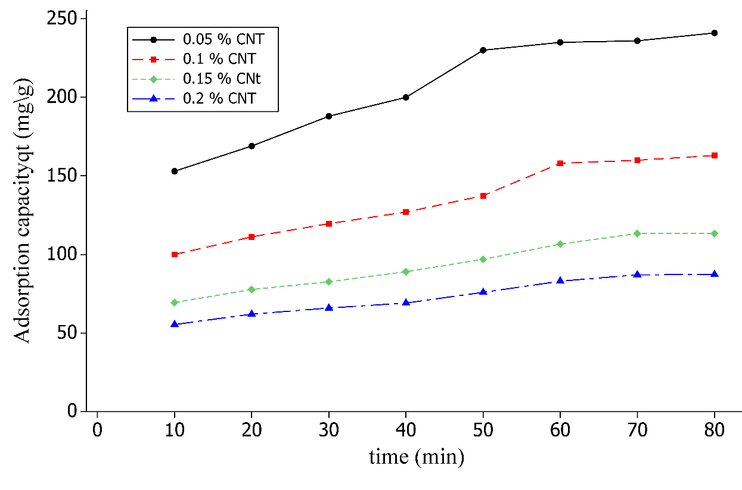

Fig. 7: Effect of contact time on the Cu(II) ion adsorption process of different MWCNTs-PVA-PEG nanocomposite hydrogels.

Effect of initial adsorbate concentration
Fig. 8 shows the effect of Cu (II) ion concentrations on the adsorption process using initial Cu(II) ion concentrations from 50 to 500 mg/L dosage and (0.05, 0.1, 0.15, 0.2 %) MWCNTs-PVA-PEG hydrogels at pH 6 for 80 min. It was observed that an increase in the amount of Cu(II) ion removed per unit mass from 89.5 to 536.0 mg g^{–1}, from 46.0 to 290.0, 31.43 to 206.60 and 24.1 to 165.5 mg g^{–1} were obtained for 0.05, 0.1, 0.15, 0.2 % MWCNTs nanocomposite hydrogels, respectively, after 80 min. higher initial concentrations of Cu(II) ion enhanced the amount adsorbed due to the increase of ability to overcome the mass transfer resistance found in the interface between the solid and solution (Tong, et.al, 2011). Similar trends for the removal of Cu(II) ion from aqueous solution have been reported (Yu , et al, 2000, and Ekmekyapar, et al, 2006).

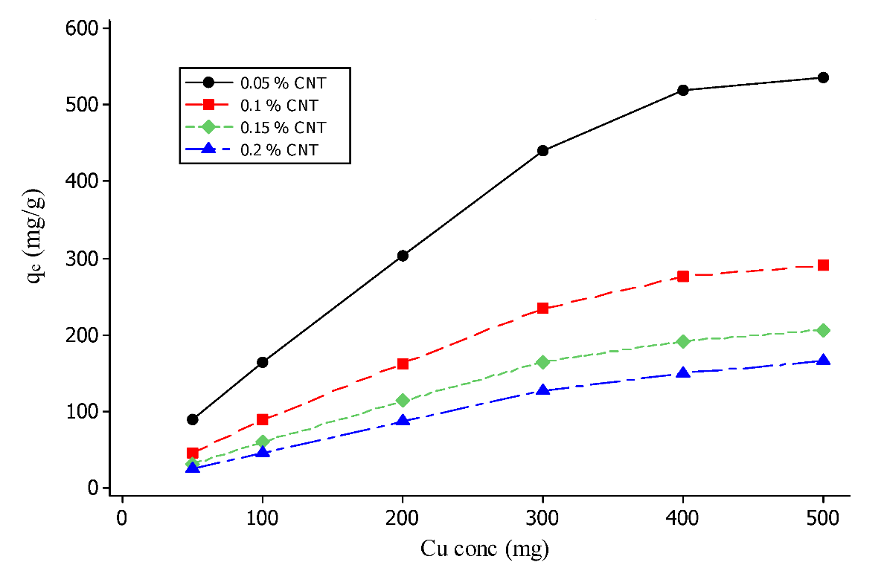

Fig. 8. Effect of Cu(II) ion concentrations on the adsorption process of different MWCNTs-PVA-PEG nanocomposite hydrogels.

Adsorption isotherm of Cu(II) ion
The experimental data were analyzed using the Langmuir and Freundlich adsorption isotherm models. The Langmuir isotherm model used to study the formation of a uniform monolayer adsorbate on the outer surface of the hydrogel adsorbent (Langmuir,, 1916). The Langmuir isotherm equation can be described as per the following linear form equation 3:

(3)

where C_{e} is the equilibrium concentration of Cu (II) ion in mg/L, q_{e} (mg/g) is the amount of Cu (II) ion adsorbed at equilibrium, Q_{m} (mg/g) is the maximum capacity of monolayer coverage and k_{a} (L/mg) is the constant of Langmuir isotherm.
The Freundlich isotherm model describes the adsorption on a heterogeneous surface with un-uniform energy [Freundlich, 1906]. The Freundlich isotherm can be described as the following linear equation 4:

(4)

where k_{F} (mg/g) is the Freundlich isotherm constant and n is the adsorption intensity.
The results of isotherm are shown in Figs. 9, 10 and summarized in Table 2. Depending on the correlation coefficients, it was found out that the equilibrium data was best described by Langmuir isotherm model rather than Freundlich isotherm model. The adsorption capacity was in order 0.05% MWCNTs (645.1 mg/g) ˃ 0.1% MWCNTs (334.4 mg/g) ˃ 0.15% MWCCNTs (238.09 mg/g) > 0.2% MWCNTs (185.09 mg/g) and they are compared with other carbon materials in Table 3. It was observed that a more significant increase in sorption uptake of Cu(II) was obtained by using MWCNTs- PEG-PVA nanocomposite than that with MWCNTs-Fe₂O₄, and other functionalized MWCNTs. Thus, the results reported in this study were highly favorable over the data obtained from other studies in Table 3.
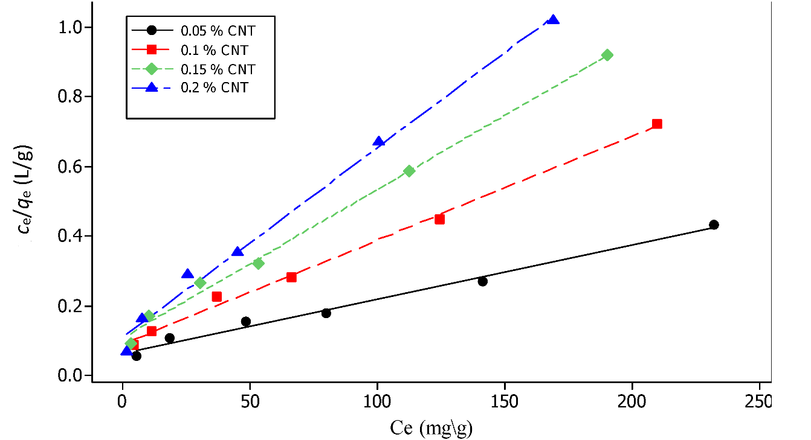

Fig. 9: Langmuir isotherm model for Cu (II) ion adsorption on (0.05, 0.1, 0.15, 0.2%) MWCNTs-PVA-PEG nanocomposite hydrogels.

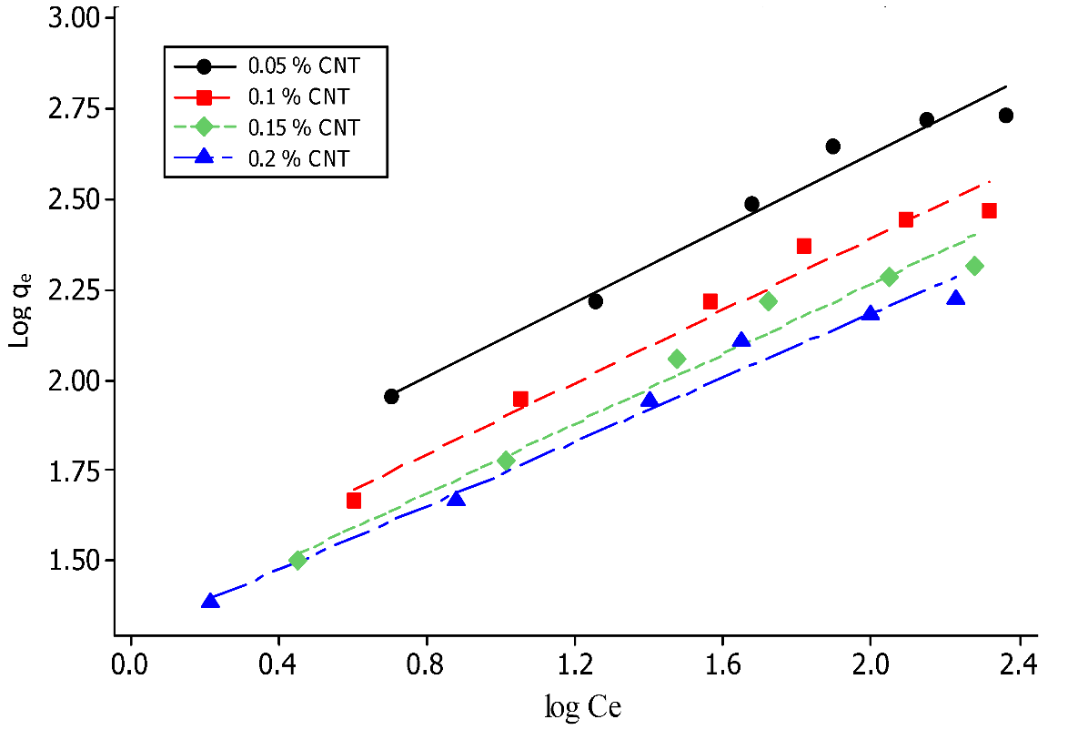

Fig. 10: Freundlich isotherm model for Cu (II) ion adsorption on (0.05, 0.1, 0.15, 0.2%) MWCNTs-PVA-PEG nanocomposite hydrogels.

Table 2: Fitting parameters for Langmuir and Freundlich isotherm models on (0.05, 0.1, 0.15, 0.2%) MWCNTs-PVA-PEG hydrogels.
Model | MWCNTs-PVA-PEG hydrogel
Model | 0.05 % | 0.1 % | 0.15 % | 0.2 %
Langmuir isotherm  Q_{m} (mg/g)  k_{a} (L/mg)  R² | 645.10  0.023  0.987 | 334.40  0.033  0.996 | 238.09  0.038  0.995 | 185.09  0.049  0.992
Freundlich isotherm  n  k_{F}  R² | 1.96  39.71  0.981 | 2.00  24.72  0.978 | 2.07  19.86  0.978 | 2.26  19.72  0.986

Table 3: Comparison of Langmuir maximum capacity (Q_{m}) for Cu (II) ion adsorbed onto various carbon-structured materials.
Adsorbent | Condition | Q_{m} (mg/g) | Reference
MWCNTs-PVA-PEG | pH 6, 0.05% MWCNTs, 80 min | 645.10 | This work
P-MWCNTs | pH 7.0, 250 mg dose, 120 min. | 0.080 | (Kosa, et.al, 2012)
P-MWCNTs | pH 7.0, .125 mg dose, 120 min. | 0.398 | (Abdel Salam, 2013)
MWCNTs-COOH | pH 7.0, 30 mg dose, 120 min, 293 K | 12.34 | (Mobasherpour, et.al, 2014)
MWCNTs/Fe₂O₄ | pH 5.50, 40 h, 353 K | 8.920 | (Hu, et.al, 2011)
MWCNTs-COOH | pH 5.0, 50 mg dose, 24 h. | 19.44 | (Oyetade, et.al. 2016)
MWCNTs-ttpy | pH 5.0, 50 mg dose, 24 h. | 31.65 | (Oyetade, et.al. 2016)

Kinetic studies
To investigate the mechanism of Cu(II) ion adsorption on the MWCNTs-PVA-PEG nanocomposite hydrogel surface and examine the potential rate-controlling step, the capability of pseudo-first order (Lagergren, 1898), and pseudo second order (Ho& McKay, 1999) kinetic models was examined in this study. The two kinetic models can be expressed in the linear forms as per the following equations 5 and 6:
(5)
(6)
where q_{e} and q_{t} are the adsorption capacity at equilibrium and time t, respectively (mg/g), k₁ (min^{–1}) is the rate constant of pseudo first order adsorption, while k₂ (g/mg min) is the rate constant of pseudo second order adsorption. Fig. 11 shows the plot log(q_{e} – q_{t}) against time which representing the linear form of pseudo-first order kinetic model, and Fig. 12 shows the plot t/q_{t} against time which representing the linear form of pseudo-second order kinetic model, and Table 4 illustrate the fitting parameters for the first and second order kinetic.
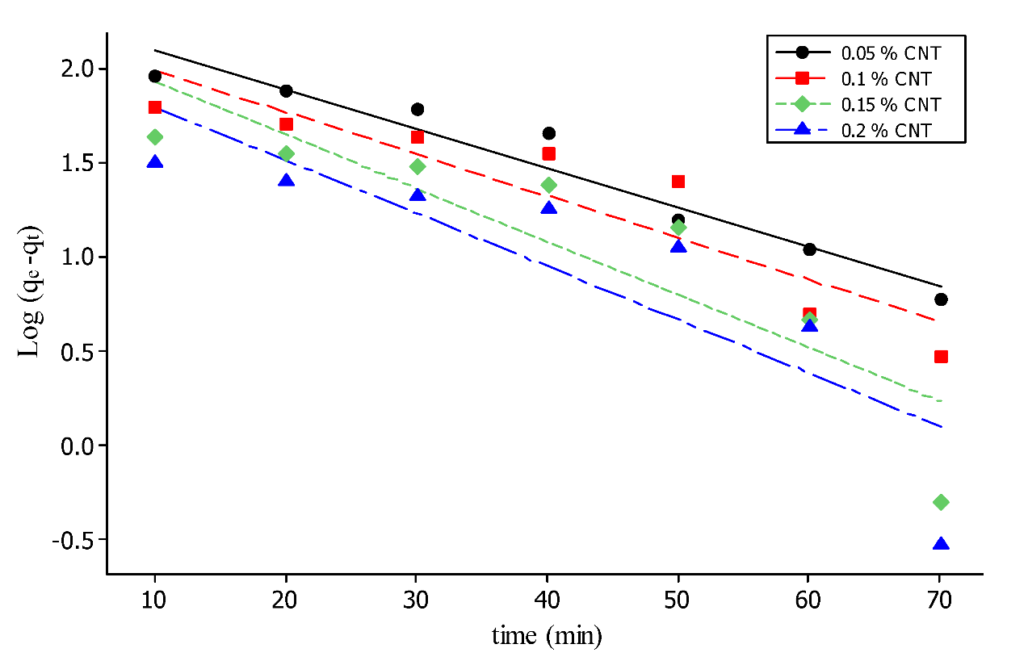

Fig. 11: Pseudo-first-order kinetic plot for Cu (II) ion adsorption using (0.05, 0.1, 0.15, 0.2%) MWCNTs-PVA-PEG nanocomposite hydrogels.
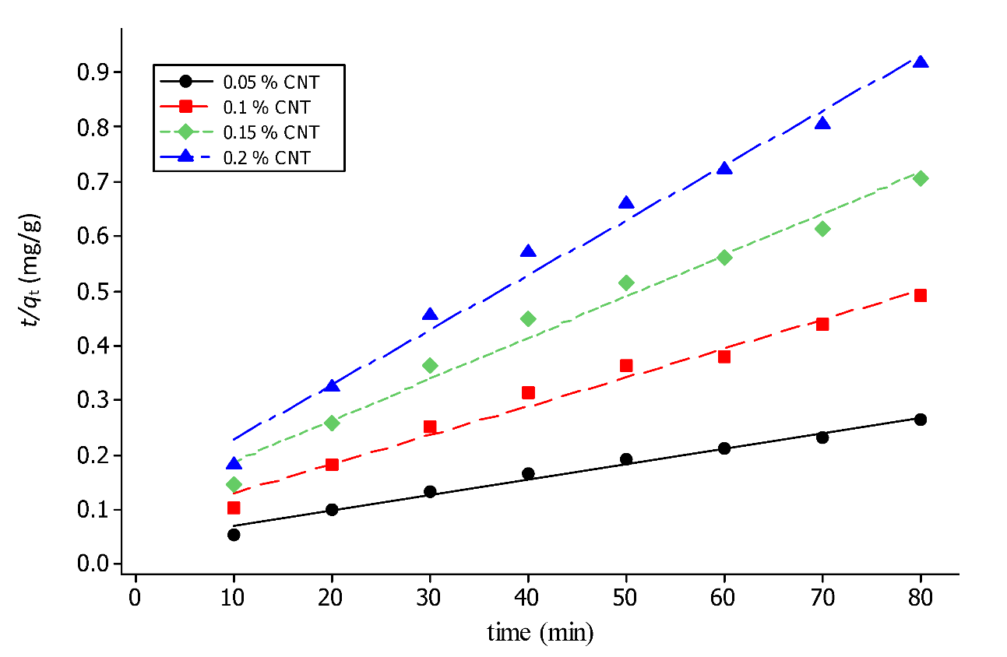

Fig. 12. Pseudo-second-order kinetic plot for Cu (II) ion adsorption using (0.05, 0.1, 0.15, 0.2%) MWCNTs-PVA-PEG nanocomposite hydrogels.
The values of the correlation coefficients showed that the adsorption kinetics fits better to the pseudo-second-order model rather than to the pseudo-first-order model (Table 4). Therefore, the rate-limiting step for Cu(II) ion adsorption onto the prepared hydrogel may be due to the interaction through the sharing or exchanging of electrons between hydroxyl groups on the hydrogel and Cu²⁺ ion (Jung, et.al, 2012). Hence, this indicates that the rate of removal of Cu²⁺ ion from aqueous solution was determined by a bimolecular interaction between the adsorbate and active sites on the adsorbents. Similar results have been reported by Ho and McKay [(Ho& McKay, 1999)], Yu et al. (Yu, et.al, 2000), and Mobasherpour et al. (Mobasherpour, et.al, 2014) for removal of Cu²⁺ ion from aqueous solutions.

Table 4: Fitting parameters for first and second order kinetic for adsorption of Cu(II) ion onto (0.05, 0.1, 0.15, 0.2%) MWCNTs-PVA-PEG nanocomposite hydrogels.
Conc. of MWCNTs | q_{e} Exp.  mg/g | Pseudo-first order |  |  | Pseudo-second order
Conc. of MWCNTs | q_{e} Exp.  mg/g | k₁(L/min) | q_{e} cal. | R² | k₂ | q_{e} cal (mg/g) | R²
0.05 % | 246 | 0.0480 | 203.704 | 0.944 | 0.104 | 248.7 | 0.985
0.1 % | 163.2 | 0.051 | 164.816 | 0.842 | 0.078 | 166.5 | 0.978
0.15 % | 113.8 | 0.065 | 164.437 | 0.778 | 0.079 | 114.9 | 0.979
0.2 % | 87.3 | 0.064 | 120.226 | 0.733 | 0.087 | 90.9 | 0.985

Recyclability test
Five cycles of adsorption–desorption of Cu(II) ions onto MWCNTs-PEG-PVA nanocomposite hydrogel were carried out for the initial Cu(II) ion concentration of 200 mg L⁻¹ and hydrogel with 0.1 % MWCNTs. Desorption of Cu(II) ions from the hydrogel adsorbent was carried out via treatment with 0.1 M HCl solution, then neutralized by 0.1 M NaOH solution and finally washed with double distilled water for the next cycle and the results are illustrated in Fig. 13. The removal efficiency of Cu(II) ions by the regenerated hydrogel is 79.3% for the first cycle and about 76.4, 73.8, 70.1 and 65.5 % for second, third, fourth and fifth cycle, respectively. That proves the efficient reusability of the newly prepared MWCNTs-PEG-PVA nanocomposite hydrogel.
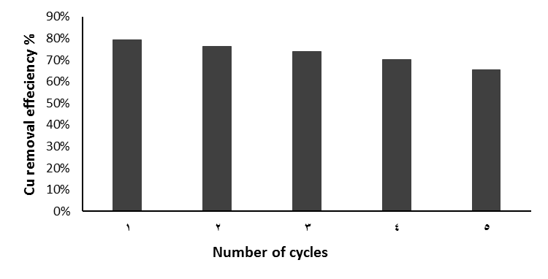

Fig. 13: Five cycles of Cu (II) ion adsorption–desorption using 0.10 % MWCNTs-PVA-PEG nanocomposite hydrogel.

Conculosion

This study provides the possibility of producing a new adsorbent hydrogel from MWCNTs- PVA-PEG where SEM image of MWCNTs-PVA-PEG indicated the good dispersion of MWCNTs into the polymers. XRD result showed that the observed peak for MWCNTs pattern, was not present in the nanocomposite hydrogel, which indicated the good dispersion of MWCNTs into the nanocomposite hydrogel.
Also FTIR results emphasized the attachment of MWCNTs with the polymers. Incorporation of MWCNTs as nanofiller into PVA-PEG hydrogel showed higher thermal stability and char residue than that without MWCNTs. In addition the presence of MWCNTs into the nanocomposite matrix increased the mechanical properties and water uptake for the nanocomposites PVA-PEG. The present study showed the high removal efficiency of MWCNTs-PVA-PEG nanocomposite hydrogel as adsorbent for the removal of Cu (II) ions from aqueous solution. The maximum adsorption of Cu (II) ions was obtained at equilibrium time of 80 min, and pH 6. Isotherm studies revealed that Langmuir model described better the equilibrium data of Cu (II) ion compared with Freundlich isotherm model. The adsorption of Cu (II) ion followed the pseudo-second order model rather than the pseudo-first-order model. The removal efficiency of Cu (II) ions by the regenerated MWCNTs-PVA-PEG nanocomposite hydrogel proved good reusability of the new prepared hydrogel.

REFERENCES

Abdel Salam, M. (2013). Removal of heavy metal ions from aqueous solutions with multi-walled carbon nanotubes: Kinetic and thermodynamic studies. Inte. J. Environ. Sci. Technol., 10: 677– 688.
Abraham, N.; Kumar, R.; Misra, K. and Jain, K. (2012). Poly (vinyl alcohol)-Based MWCNT Hydrogel for Lead Ion Removal from Contaminated Water. Appl. Polym. Sci., 125: 670-674.
Abu Ghalia, M. and Dahman, Y. (2015). Radiation crosslinking polymerization of poly (vinyl alcohol) and poly (ethylene glycol) with controlled drug release. J. Polym. Res., 22: 218.
Ajitha, P.; Vijayalakshmi, P.; Saranya, M.; Gomathi, T.; Rani, K.; Sudha, P. N. and Anil, S. (2017). Removal of toxic heavy metal lead (II) using chitosan oligosaccharide-graft-maleic anhydride/polyvinyl alcohol/silk fibroin composite. Int. J. Biol. Macromol., 104: 1469-1482.
Brumfiel, G. (2003). Nanotechnology: a little knowledge. Nature, 424: 246–248.
Dil, E.A.; Ghaedi, M. and Asfaram, A. (2017). The performance of nanorods material as adsorbent for removal of azo dyes and heavy metal ions: application of ultrasound wave, optimization and modeling. Ultrason. Sonochem., 34: 792–802.
Ekmekyapar, F.; Aslan, A.; Bayhan, Y.K. and Cakici, A. (2006). The role of nanomaterials as effective adsorbents and their applications in wastewater treatment. J. Hazard. Mater., 137: 293–298.
El Nemr, A. (2009). Potential of pomegranate husk carbon for Cr(VI) removal from wastewater: kinetic and isotherm studies. J. Hazard. Mater., 161: 132-141.
El Nemr, A. (Editor). (2012). Non-Conventional textile waste water treatment. Nova Science Publishers, Inc. Hauppauge New York. [Hard cover ISBN: 978-1-62100-079-2, e-book ISBN: 978-1-62100-228-4] 267 pages.
El Nemr, A.; El-Sikaily, A. and Khaled, A. (2010). Modeling of adsorption isotherms of Methylene Blue onto rice husk activated carbon. Egypt. J. Aquat. Res. (36): 403-425.
El-Sikaily, A.; El Nemr, A. and Khaled, A. (2011). Copper sorption onto dried red alga Pterocladia capillacea and its activated carbon. Chem. Eng. J., 168: 707–714.
Freundlich, H. M. F. (1906). Uber die adsorption in losungen, Z. Phys. Chem. (Leipzig)., 57: 385–470.
Gao, H.; Sun, Y.; Zhou, J.; Xu, R. and Duan, H. (2013). Mussel-Inspired Synthesis of Polydopamine-Functionalized Graphene Hydrogel as Reusable Adsorbents for Water purification, Appl. Mate. Interfaces., 5: 425−432.
Haung, Z.; Liu, S.; Zhang, B.; Xu, L. and Hu, X. (2012). Equilibrium and kinetics studies on the absorption of Cu (II) from the aqueous phase using a β-cyclodextrin-based adsorbent. Carbohydr. Polym., 88: 608-617.
Ho, Y. S. and McKay, G. (1999). Pseudo second order model for adsorption process. Proc. Biochem. 34: 451–465.
Hu, J.; Zhao, D. and Wang, X. (2011). Removal of Pb (II) and Cu (II) from aqueous solution using multiwalled carbon nanotubes/iron oxide magnetic composites. Water Sci. Technol., 63: 917–923.
Jamnongkan, T.; Kantaerot, K.; Niemtang, K.; Pansila, P.P. and Wattanakornsiri, A. (2014). Kinetics and mechanism of adsorptive removal of copper from aqueous solution with poly (vinyl alcohol) hydrogel. Transform. Nonferr. Mater. Soci. China., 24: 3386−3393.
Jung, G.; Yun, J. and Kim, H. (2012). Temperature and pH-Responsive Release Behavior of PVA/ PAAc/PNIPAAm/MWCNTs Nanocomposite Hydrogels. Carbonlett., 13: 173-177.
Kosa, S.A.; Al-Zhrani, G. and Abdel Salam, M. (2012). Removal of heavy metals from aqueous solutions by multi-walled carbon nanotubes modified with 8-hydroxyquinoline. Chem. Eng. J., 181–182: 159–168.
Lagergren, S. (1898). Zur theorie der sogenannten Adsorption geloster stoffe, Kungligasvenska vetenskapsakademiens. Handlingar, 24: 1–39.
Langmuir, I. (1916). The constitution and fundamental properties of solids and liquids. J. Am. Chem. Soc., 38: 2221–2295.
Liue, Z.; Yang, Z. and Luo, Y. (2012). Swelling, pH sensitivity and mechanical properties of poly (acrylamide-Co-sodium methacrylate) nanocomposite hydrogels impregnated with carboxyl-carbon nanotube. Polm. Comp., 17: 665-674.
Lu, P.; Hsieh, Y. (2010). Multiwalled Carbon Nanotube (MWCNT) Reinforced Cellulose Fibers by Electrospinning Fiber and Polymer Science. Appl. Mater. Interfaces., 2: 2413–2420.
Ma, L.; Dong, X.; Chen, M.; Zhu, L.; Wang, C.; Yang, F. and Dong, Y. (2017). Fabrication and Water Treatment Application of Carbon Nanotubes (CNTs)-Based Composite Membranes: A Review, Membrane (basel), 7(1): 16.
Machida, M.; Mochimaru, T. and Tatsumoto, H. (2006). Lead (II) adsorption onto the graphene layer of carbonaceous materials in aqueous solution. Carbon., 44: 2681–2688.
Malikova, E.Y.; Muradovb, M.B.; Akperova, O.H.; Eyvazovab, G.M.; Puskásc, R.; Madarászc, D.; Nagyc L.; Kukoveczc, Á. and Kónyac, Z. (2014). Synthesis and characterization of polyvinyl alcohol based multiwalled carbon nanotube nanocomposites. Physica E. 61: 129-134.
Mansur, H.S.; Orefice, R.L. and Mansur, A.A.P. (2004). Characterization of poly (vinyl alcohol)/poly (ethylene glycol) hydrogels and PVA-derived hybrids by small-angle X-ray scattering and FTIR spectroscopy. Polymer, 45: 7193–7202.
Mobasherpour, I.; Salahi, E. and Ebrahimi, M. (2014). Thermodynamics and kinetics of adsorption of Cu(II) from aqueous on multi walled carbon nanotubes. J. Saudi Chem. Soc., 18: 792–801.
Najam, R.; Muzaffar, S. and Andrabi, A. (2016). Removal of Cu(II), Zn(II) and Cd(II) ions from aqueous solutions by adsorption on walnut shell-Equilibrium and thermodynamic studies: treatment of effluents from electroplating industry. Desal. Wat. Treat., 57: 27363-27373.
Naskar, A. K. (2010). in: Thermal Analysis of Rubbers and Rubbery Materials, 1st Edn., Chapter 3, P.P. De, N.R. Chowdhury and N.K. Dutta, Pub. By Smithers Rapra Publishing, hawbury, U.K., P 117.
Olvera, R.C.; Silva, S.L.; Belmont, E.R. and Lau, E.Z. (2017). Review of nanotechnology value chain for water treatment applications in Mexico. Res. Effic. Technol., 3: 1-11.
Oyetade, O.A.; Nyamori, V.O.; Martincigh, B.S. and Jonnalagadda, S.B. (2016). Nitrogen-functionalised carbon nanotubes as a novel adsorbent for the removal of Cu(II) from Aqueous solution. RSC. Adv., 6: 2731.
Özkahraman, B. and Irmak, E.T. (2017). Carbon nanotube based polyvinylalcohol-polyvinylpyrolidone nanocomposite hydrogels for controlled drug delivery applications. J. Sci. Technol. A- Appl. Sci. Eng., 18: 543-553.
Pham, Q.L.; Haldorai, Y.; Nguyen, V.H.; Tuma, D. and Shim, J. (2011). A facile synthesis of poly (p-phenylenediamine)/MWCNT nanocomposites and characterization for the investigation of structural effects of carbon nanotubes. J. Bull. Mater. Sci., 34: 37–43.
Sadegh, H.; Ghoshekandi, R.S.; Masjedi, A.; Mahmoodi, Z. and Kazemi, M. (2016). A review on Carbon nanotubes adsorbents for the removal of pollutants from aqueous solutions. I. J. Nano Dimens., 7: 109.
Sadegh, H.; Ali, G.A.M.; Gupta, V.K.; Makhlouf, A.S.H.; Shahryari-ghoshekandi, R.; Nadagouda, M.N.; Sillanpa, M. and Megiel, Z. (2017). The role of nanomaterials as effective adsorbents and their applications in wastewater treatment. J. Nanostruct. Chem., 7: 1–14.
Sarker, K. and Ullaha, R. (2013). Determination of Trace Amount of Cu(II) Using UV-Vis. Spectrophotometric Method. Int. J. Chem. Stud., 1: 2321-4902.
Savage, N. and Diallo, M.S. (2005). Nanomaterials and water purification: opportunities and challenges. J. Nanopart. Res., 7: 331–342.
Suzuki, A. (2015). Swelling and mechanical properties of physically crosslinked poly (vinyl alcohol) hydrogels. SAGE j., 229: 828-844.
Theron, J.; Walker, J. and Cloete, T. (2008). Nanotechnology and water treatment: applications and emerging opportunities. Crit. Rev. Microbiol., 34: 43–69.
Tong, K.S.; Kassim, M.J. and Azraa, A. (2011). Adsorption of copper ion from its aqueous solution by a novel biosorbent Uncaria gambir: Equilibrium, kinetics, and thermodynamic studies. Chem. Eng. J., 170: 145–153.
Volynets, N.I.; Poddubskaya, O.G.; Demidenko, M.I.; Lyubimov, A.G.; Kuzhir, P.P.; Suslyaev, V.I., Pletnev, M.A. and Zicans, J. (2017). Analysis and thermogr-avmetric properties of composite materials based on PVA/MWCNT and styrene-acrylic copolymer/MWCNT. Russian Phys. J., 60: 717-722.
Yang, X.; Liu, Q.; Chen, X.; Yu, F. and Zhu, Z. (2008). Investigation of PVA/ws-chitosan hydrogels prepared by combined γ-irradiation and freeze-thawing. Carbohydr. Polym., 73: 401–408.
Yan, L.Y.; Chen, H.; Li, P.; Kim, D.H. and Chan-Park, M.B. (2012). Finely Dispersed Single-Walled Carbon Nanotubes for Polysaccharide Hydrogels. Appl. Mater. Interfaces., 4: 4610−4615.
Yan, Y.H.; Cui, J.; Chan-Park, M.B.; Wang, X. and Wu, Q.Y. (2007). Systematic studies of covalent functionalization of carbon nanotubes via argon plasma-assisted UV grafting. Nanotech., 18: 24-42.
Yu, B.; Zhang, Y.; Shukla, A.; Shukla, S.S. and Dorris, K.L. (2000). The removal of heavy metal from aqueous solutions by sawdust adsorption-removal of copper. J. Hazard. Mater., B80(80): 33–42.
Yun, J.; Im, J.S.; Lee, Y.-S. and Kim, H. I. (2011), Electro-responsive transdermal drug delivery behavior of PVA/PAA/MWCNT nanofibers, Europ. polym. J., 47: 1893-1902.

ARABIC SUMMARY

